**Web Programming – CS4032**

**Assignment 02 PART B**

**Name: Razeen Shahid & Ahmad Rayyan**

**Roll Number: 21F-9224 & 21F-9266**

**Section: BSCS-6B**

**Course Instructor: Muhammad Hannan Farooq**

TASK 01:

HTML:

<!DOCTYPE html>

<html lang="en">

<head>

  <title>Bootstrap Example Task 01</title>

  <meta charset="utf-8">

  <meta name="viewport" content="width=device-width, initial-scale=1">

  <link href="https://cdn.jsdelivr.net/npm/bootstrap@5.3.2/dist/css/bootstrap.min.css" rel="stylesheet">

</head>

<body>

  <div class="container mt-3">

    <h1>Task 01</h1>

    <br>

    <table class="table">

      <tbody>

        <tr class="table-success">

          <td class="text-success">Feel good about Bootstrap</td>

        </tr>

        <tr class="table-info">

          <td class="text-info">Feel informed about Bootstrap</td>

        </tr>

        <tr class="table-warning">

          <td class="text-warning">Feel warned about Bootstrap</td>

        </tr>

        <tr class="table-warning">

          <td class="text-warning">Maybe I should read the docs...</td>

        </tr>

        <tr class="table-danger text-danger">

          <td class=" text-danger">Danger Zone</td>

        </tr>

        <tr class="table-danger">

          <td class=" text-danger">I really should read the docs...</td>

        </tr>

      </tbody>

    </table>

  </div>

</body>

</html>

OUTPUTS:

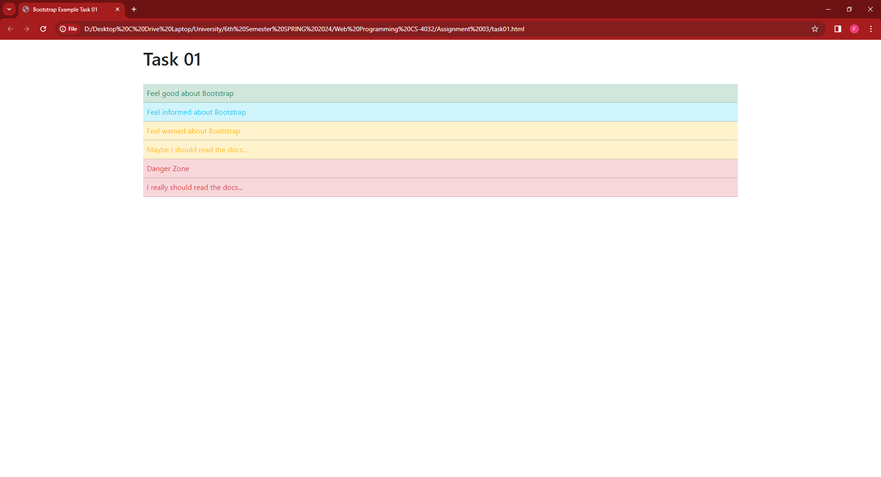

TASK 02:

HTML:

<!DOCTYPE html>

<html lang="en">

<head>

    <meta charset="UTF-8">

    <meta name="viewport" content="width=device-width, initial-scale=1.0">

    <title>Bootstrap Example Task 02</title>

    <link href="https://cdn.jsdelivr.net/npm/bootstrap@5.3.2/dist/css/bootstrap.min.css" rel="stylesheet">

</head>

<body>

    <div class="container mt-3 text-center">

        <h2>Welcome to our website!</h2>

        <h4>Look at this button! Wow, let's click on it!</h4>

        <div class="d-grid">

            <button type="button" class="btn btn-primary btn-block">Learn more</button>

        </div>

    </div>

    <br>

    <div class="container mt-3">

        <h2>Let's look at some random pictures!<span> from http://lorempixel.com</span></h2>

        <br>

        <div class="row">

            <div class="col-md-4">

                <div class="card">

                    <img class="card-img-top" src="picture1.jpg" alt="Card image cap">

                    <div class="card-body">

                        <p class="card-text">Lorem ipsum dolor sit amet, consectetur adipiscing elit, sed do eiusmod

                            tempor incididunt ut labore et dolore magna aliqua. Ut enim ad minim veniam, quis nostrud

                            exercitation ullamco laboris nisi ut aliquip ex ea commodo consequat. Duis aute irure dolor

                            in reprehenderit in voluptate velit esse cillum dolore eu fugiat nulla pariatur. Excepteur

                            sint occaecat cupidatat non proident, sunt in culpa qui officia deserunt mollit anim id est

                            laborum.</p>

                    </div>

                </div>

            </div>

            <div class="col-md-4">

                <div class="card">

                    <img class="card-img-top" src="picture1.jpg" alt="Card image cap">

                    <div class="card-body">

                        <p class="card-text">Lorem ipsum dolor sit amet, consectetur adipiscing elit, sed do eiusmod

                            tempor incididunt ut labore et dolore magna aliqua. Ut enim ad minim veniam, quis nostrud

                            exercitation ullamco laboris nisi ut aliquip ex ea commodo consequat. Duis aute irure dolor

                            in reprehenderit in voluptate velit esse cillum dolore eu fugiat nulla pariatur. Excepteur

                            sint occaecat cupidatat non proident, sunt in culpa qui officia deserunt mollit anim id est

                            laborum.</p>

                    </div>

                </div>

            </div>

            <div class="col-md-4">

                <div class="card">

                    <img class="card-img-top" src="picture1.jpg" alt="Card image cap">

                    <p class="card-text">Lorem ipsum dolor sit amet, consectetur adipiscing elit, sed do eiusmod tempor

                        incididunt ut labore et dolore magna aliqua. Ut enim ad minim veniam, quis nostrud exercitation

                        ullamco laboris nisi ut aliquip ex ea commodo consequat. Duis aute irure dolor in reprehenderit

                        in voluptate velit esse cillum dolore eu fugiat nulla pariatur. Excepteur sint occaecat

                        cupidatat non proident, sunt in culpa qui officia deserunt mollit anim id est laborum.</p>

                </div>

            </div>

        </div>

    </div>

    </div>

    <br><br>

    <div class="container mt-3">

        <table class="table">

            <tbody>

                <tr class="table-success">

                    <td class="text-success text-center">Thanks for Visting!</td>

                </tr>

    </div>

</body>

</html>

OUTPUTS:

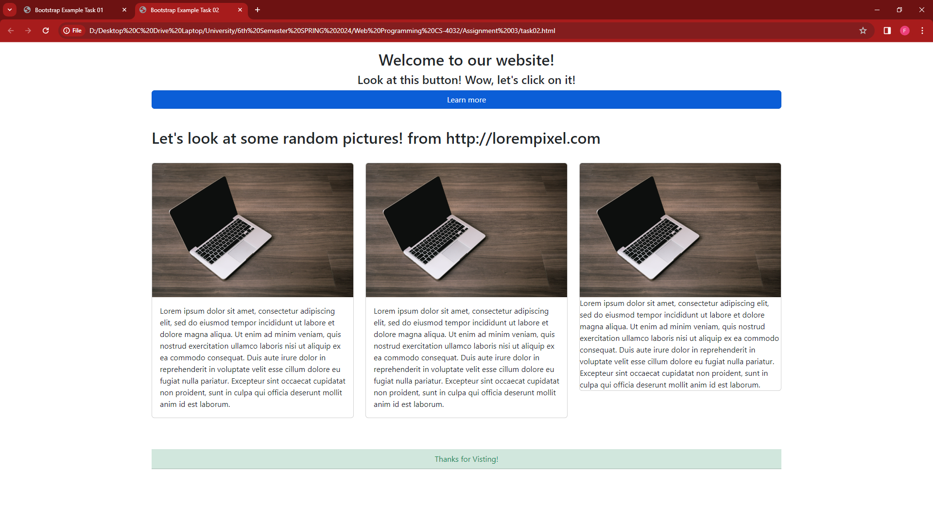

TASK 03:

HTML:

<!DOCTYPE html>

<html lang="en">

<head>

    <style>

        #intro {

            background-image: url("https://mdbootstrap.com/img/new/fluid/city/018.jpg");

            height: 100vh;

        }

    </style>

    <meta charset="UTF-8">

    <meta name="viewport" content="width=device-width, initial-scale=1, shrink-to-fit=no">

    <title>MaksWeddings</title>

    <link rel="stylesheet" href="https://stackpath.bootstrapcdn.com/bootstrap/4.5.2/css/bootstrap.min.css">

</head>

<body>

    <header>

        <nav class="navbar navbar-expand-lg navbar-light bg-light">

            <a class="navbar-brand" href="task_3.html">

                MaksWeddings

                <p style="font-size: small;">

                    Best Photography

                </p>

            </a>

            <button class="navbar-toggler" type="button" data-toggle="collapse" data-target="#navbarNav"

                aria-controls="navbarNav" aria-expanded="false" aria-label="Toggle navigation">

                <span class="navbar-toggler-icon"></span>

            </button>

            <div class="collapse navbar-collapse" id="navbarNav">

                <ul class="navbar-nav ml-auto">

                    <li class="nav-item active">

                        <a class="nav-link" href="#home">Home</a>

                    </li>

                    <li class="nav-item">

                        <a class="nav-link" href="#about">About Us</a>

                    </li>

                    <li class="nav-item">

                        <a class="nav-link" href="#services">Services</a>

                    </li>

                    <li class="nav-item">

                        <a class="nav-link" href="#contact">Contact Us</a>

                    </li>

                </ul>

            </div>

        </nav>

    </header>

    <div class="container mt-5 has-bg-img">

        <section class="has-bg-img" id="home">

            <div class="bg-image p-5 text-center shadow-1-strong rounded mb-5 text-white"

                style="background-image: url('https://mdbcdn.b-cdn.net/img/new/slides/003.webp');">

                <div class="position-relative">

                    <h1>Welcome to Your Company</h1>

                    <p>Frame your story, freeze your moments through our lenses</p>

                </div>

            </div>

        </section>

        <section id="about">

            <h2>About Us</h2>

            <div class="col-md-auto">

                <p>Welcome to MaksWeddings, where cherished moments meet timeless elegance. I'm Maks, your dedicated

                    photographer capturing the essence of love and celebration. With a passion for storytelling through

                    images, I specialize in crafting unforgettable wedding memories. Explore my portfolio for a glimpse

                    into

                    the artistry behind MaksWeddings. Let's create lasting impressions together – your love story, my

                    lens.

                </p>

                <div class="float-end">

                    <img src="home-bg.webp" alt="" class="mx-auto d-block" height="30%" width="30%">

                </div>

            </div>

        </section>

        <section id="services">

            <h2>Our Services</h2>

            <div class="row">

                <div class="col-md-4">

                    <div>

                        <div>

                            <div class=""><img decoding="async"

                                    src="https://maksweddings.pk/wp-content/uploads/2021/03/birthday-party.png" alt=""

                                    width="50" height="50" loading="lazy"></div>

                            <div class="uagb-ifb-title-wrap">

                                <h4 class="uagb-ifb-title">Birthday Party</h4>

                            </div>

                            <p>

                                Capture the joy and excitement of your birthday celebration with

                                our professional photography services. Our talented team will document every special

                                moment, from candid shots to stunning portraits, ensuring that you have beautiful

                                memories to cherish for a lifetime. Let us make your day even more memorable with our

                                expert photography skills.</p>

                        </div>

                    </div>

                </div>

                <div class="col-md-4">

                    <div>

                        <div>

                            <div>

                                <img decoding="async"

                                    src="https://maksweddings.pk/wp-content/uploads/2021/03/hearts.png" alt=""

                                    width="50" height="50" loading="lazy">

                            </div>

                            <div class="col-md-4">

                                <h3 class="">

                                    Wedding Photography

                                </h3>

                            </div>

                            <p class="">

                                Celebrate your love story with our exquisite wedding photography services. Our

                                experienced photographers will capture every magical moment, from the emotional exchange

                                of vows to the joyous celebration with loved ones. With an artistic eye and attention to

                                detail, we create timeless images that beautifully encapsulate the essence of your

                                special day.

                            </p>

                        </div>

                    </div>

                </div>

                <div class="col-md-4">

                    <div>

                        <div>

                            <div>

                                <img decoding="async"

                                    src="https://maksweddings.pk/wp-content/uploads/2021/03/animal.png" alt=""

                                    width="50" height="50" loading="lazy">

                            </div>

                            <div>

                                <h4>Product Photography</h4>

                            </div>

                            <p>

                                Capture the essence and allure of your products with our professional product

                                photography services. Our skilled photographers have an eye for detail and expertise in

                                lighting, composition, and styling. We’ll create stunning images that showcase your

                                products in their best light, helping you attract customers and boost sales.

                            </p>

                        </div>

                    </div>

                </div>

            </div>

        </section>

        <section id="contact">

            <h2>Contact Us</h2>

            <form>

                <div class="form-group">

                    <label for="name">Name</label>

                    <input type="text" class="form-control" id="name" required>

                </div>

                <div class="form-group">

                    <label for="email">Email</label>

                    <input type="email" class="form-control" id="email" required>

                </div>

                <div class="form-group">

                    <label for="message">Message</label>

                    <textarea class="form-control" id="message" rows="4" required></textarea>

                </div>

                <button type="submit" class="btn btn-primary">Submit</button>

            </form>

        </section>

    </div>

    <footer class="bg-dark text-light footer-expand-lg text-center p-3 container  mt-5">

        &copy; 2024 Your Company. All rights reserved.

    </footer>

</body>

<script src="https://code.jquery.com/jquery-3.5.1.slim.min.js"></script>

<script src="https://cdn.jsdelivr.net/npm/@popperjs/core@2.0.7/dist/umd/popper.min.js"></script>

<script src="https://stackpath.bootstrapcdn.com/bootstrap/4.5.2/js/bootstrap.min.js"></script>

</html>

OUTPUTS:

